Unreal Engine Automation Driver Test

Creating a Slate UI for Automation Testing
- Open Unreal Engine.
- Select "C++ Classes" folder in the Content Browser.
- Right Click and add a new C++ class.
- Select None for the parent class.
- Select "Private".
- Input the class name with the following format "SWidgetName.cpp".
e.g. SMainMenuWidget.cpp
- Once compiling has finished close Unreal Engine and open the "ProjectName.sln" file.
- Locate the "ProjectName.Build.cs" file and ensure the "Slate" and "Slate Core" modules are included inside of the "PrivateDependencyModuleNames" array.
- Return to the "SWidgetName.cpp" file.
- Add the includes "SlateBasics.h" and "SlateExtras.h"
- Next make the "SWidgetName" class is inheriting from "SCompoundWidget" this can't be done through Unreal Engine and has to be done manually.
- To implement the rest of the Slate UI class please follow the tutorial video "Make UI With C++: How to use Slate in Unreal Engine" and refer to the documentation "Slate Overview for Unreal Engine | Unreal Engine 5.4 Documentation | Epic Developer Community (epicgames.com)".
- When adding a Button or UI element that you would like the Automation Driver to be able to locate we will need to include the Automation Driver Meta data with the function "AddMetaData(FDriverMetaData::Id("PlayButton"))"
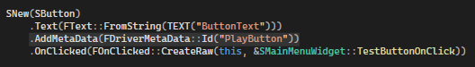

Writing a Automation Driver Test
- Open the "ProjectName.Build.cs" file and include the "AutomationDriver" Module in the "PublicDependencyModuleNames" array.
- Create a Spec type test class.
- Add the include "Developer/AutomationDriver/Public/AutomationDriverCommon.h"
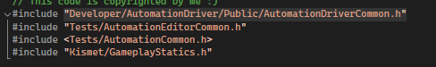
- Next inside of the Spec Define function, include a "Describe" function that contains a "BeforeEach" function.
- Inside of the "BeforeEach" we need to enable the automation driver, to do this we use the function "IAutomationDriverModule::Get().Enable();"
- Next we need to create the driver using the function "IAutomationDriverModule::Get().CreateDriver();" and assign to a "FAutomationDriverPtr" variable for future reference.
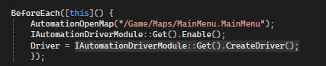
- Next we make a "It" function for the actual test. Inside the "It" function we will need to get a reference to the UI element that we are looking for. We can do this with a "FDriverElementRef" variable and using the Automation Driver's function "Driver->FindElement(By::Path("#PlayButton"))". The references can be located a variety of ways, please see the documentation for more information. Automation Driver in Unreal Engine | Unreal Engine 5.4 Documentation | Epic Developer Community (epicgames.com)
- Finally we can check the element Exists and interact with it as required.
